**THE ASSESSMENT**

**QUESTIONS:**

1. Create a SQL statement to list all managers and their titles.

SELECT dm.emp_no, t.title,

CONCAT (e.first_name, ' ', e.last_name) AS full_name

FROM dept_manager dm

INNER JOIN employees e ON dm.emp_no = e.emp_no

LEFT JOIN titles t ON t.emp_no = e.emp_no

GROUP BY dm.emp_no;

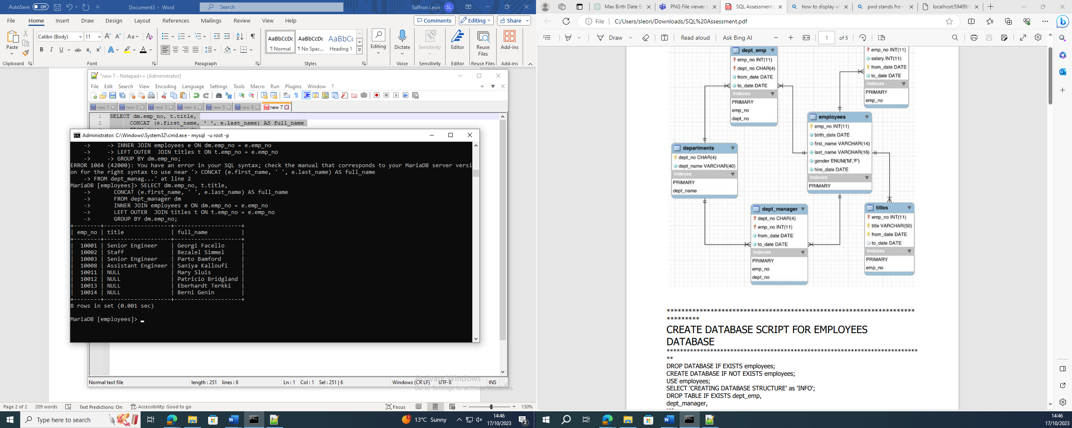

*Some employees do not have titles but are still managers so you could join them by their department number:

SELECT dm.emp_no, t.title, dm.dept_no,

CONCAT (e.first_name, ' ', e.last_name) AS full_name

FROM dept_manager dm

INNER JOIN employees e ON dm.emp_no = e.emp_no

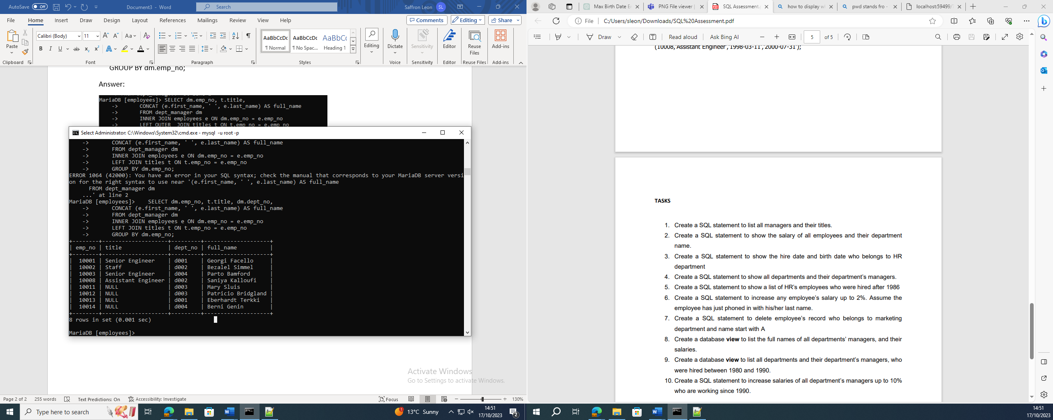 LEFT JOIN titles t ON t.emp_no = e.emp_no

GROUP BY dm.emp_no;

**2.** Create a SQL statement to show the salary of all employees and their department name.

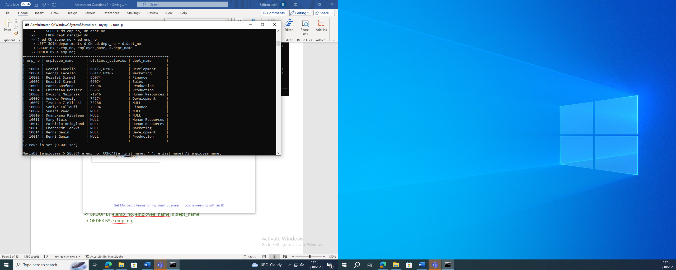SELECT

e.emp_no,

CONCAT(e.first_name, ' ', e.last_name) AS employee_name,

MAX(s.salary) AS salary,

d.dept_name

FROM employees e

LEFT JOIN salaries s ON e.emp_no = s.emp_no

LEFT JOIN dept_emp de ON e.emp_no = de.emp_no

LEFT JOIN dept_manager dm ON e.emp_no = dm.emp_no

LEFT JOIN departments d ON (de.dept_no = d.dept_no OR dm.dept_no = d.dept_no)

GROUP BY e.emp_no, employee_name, d.dept_name

ORDER BY e.emp_no;

OR

-- Create a temporary table with the data

CREATE TEMPORARY TABLE temp_all_data AS

SELECT e.emp_no, CONCAT(e.first_name, ' ', e.last_name) AS employee_name, s.salary, d.dept_name

FROM employees e

LEFT JOIN salaries s ON e.emp_no = s.emp_no

LEFT JOIN dept_emp de ON e.emp_no = de.emp_no

LEFT JOIN dept_manager dm ON e.emp_no = dm.emp_no

LEFT JOIN departments d ON (de.dept_no = d.dept_no OR dm.dept_no = d.dept_no);

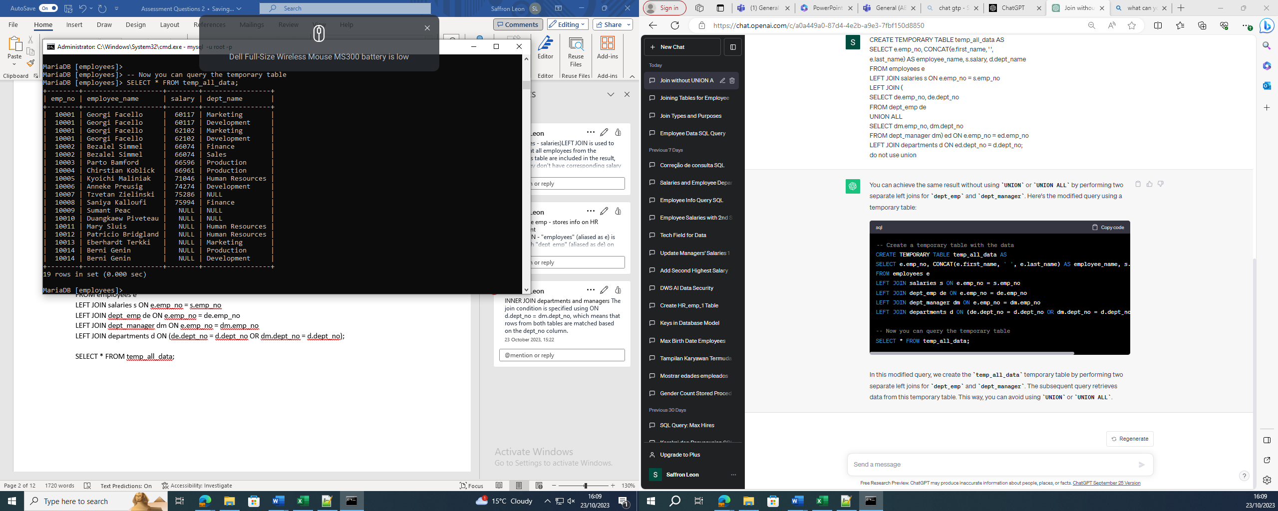SELECT * FROM temp_all_data;

**3.** Create a SQL statement to show the hire date and birth date who belongs to HR department.

**Assuming I do not know the name of the department and I am just looking for HR.**

SELECT e.hire_date, e.birth_date , d.dept_name

FROM employees e

LEFT JOIN dept_emp de ON e.emp_no = de.emp_no

LEFT JOIN departments d ON de.dept_no = d.dept_no

WHERE d.dept_name LIKE '%H%R%'

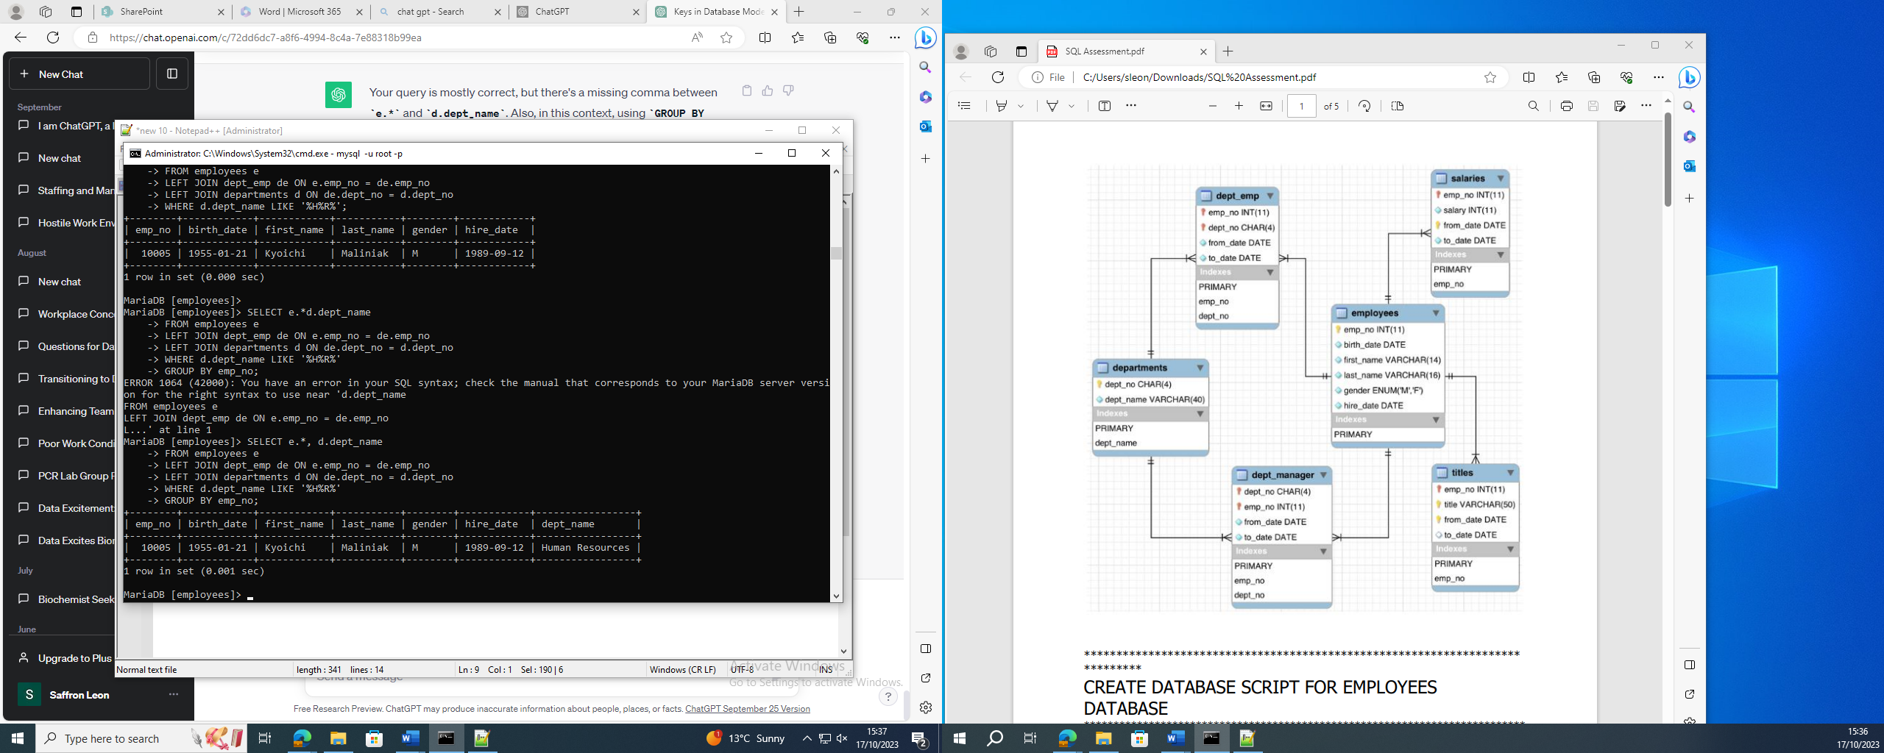GROUP BY emp_no;

**OR if I know the name of the HR department:**

SELECT e.hire_date, e.birth_date , d.dept_name

FROM employees e

LEFT JOIN dept_emp de ON e.emp_no = de.emp_no

LEFT JOIN departments d ON de.dept_no = d.dept_no

WHERE d.dept_name LIKE '%Human Resources%'

GROUP BY emp_no;

Also, the question says belong to not works in so technically more than one person belongs to HR.

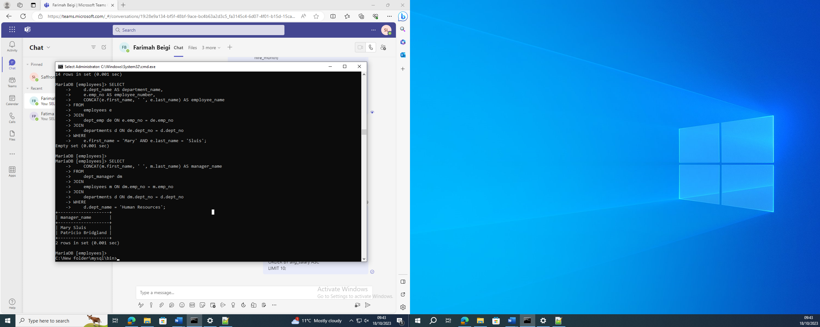

SELECT CONCAT(m.first_name, ' ', m.last_name) AS manager_name

FROM

dept_manager dm

JOIN

employees m ON dm.emp_no = m.emp_no

JOIN

departments d ON dm.dept_no = d.dept_no

WHERE

d.dept_name = 'Human Resources';

**\*Correction: without using a union and using LEFT JOINS**

WITH all_HR_emp AS

(SELECT e.emp_no, e.first_name, e.last_name, d.dept_name, d.dept_no, e.hire_date, e.birth_date

FROM employees e

LEFT JOIN dept_manager dm ON dm.emp_no = e.emp_no

LEFT JOIN dept_emp de ON de.emp_no = e.emp_no

LEFT JOIN departments d ON d.dept_no = de.dept_no OR d.dept_no = dm.dept_no)

SELECT * FROM all_HR_emp WHERE dept_name = 'Human Resources' OR dept_no = 'd003';

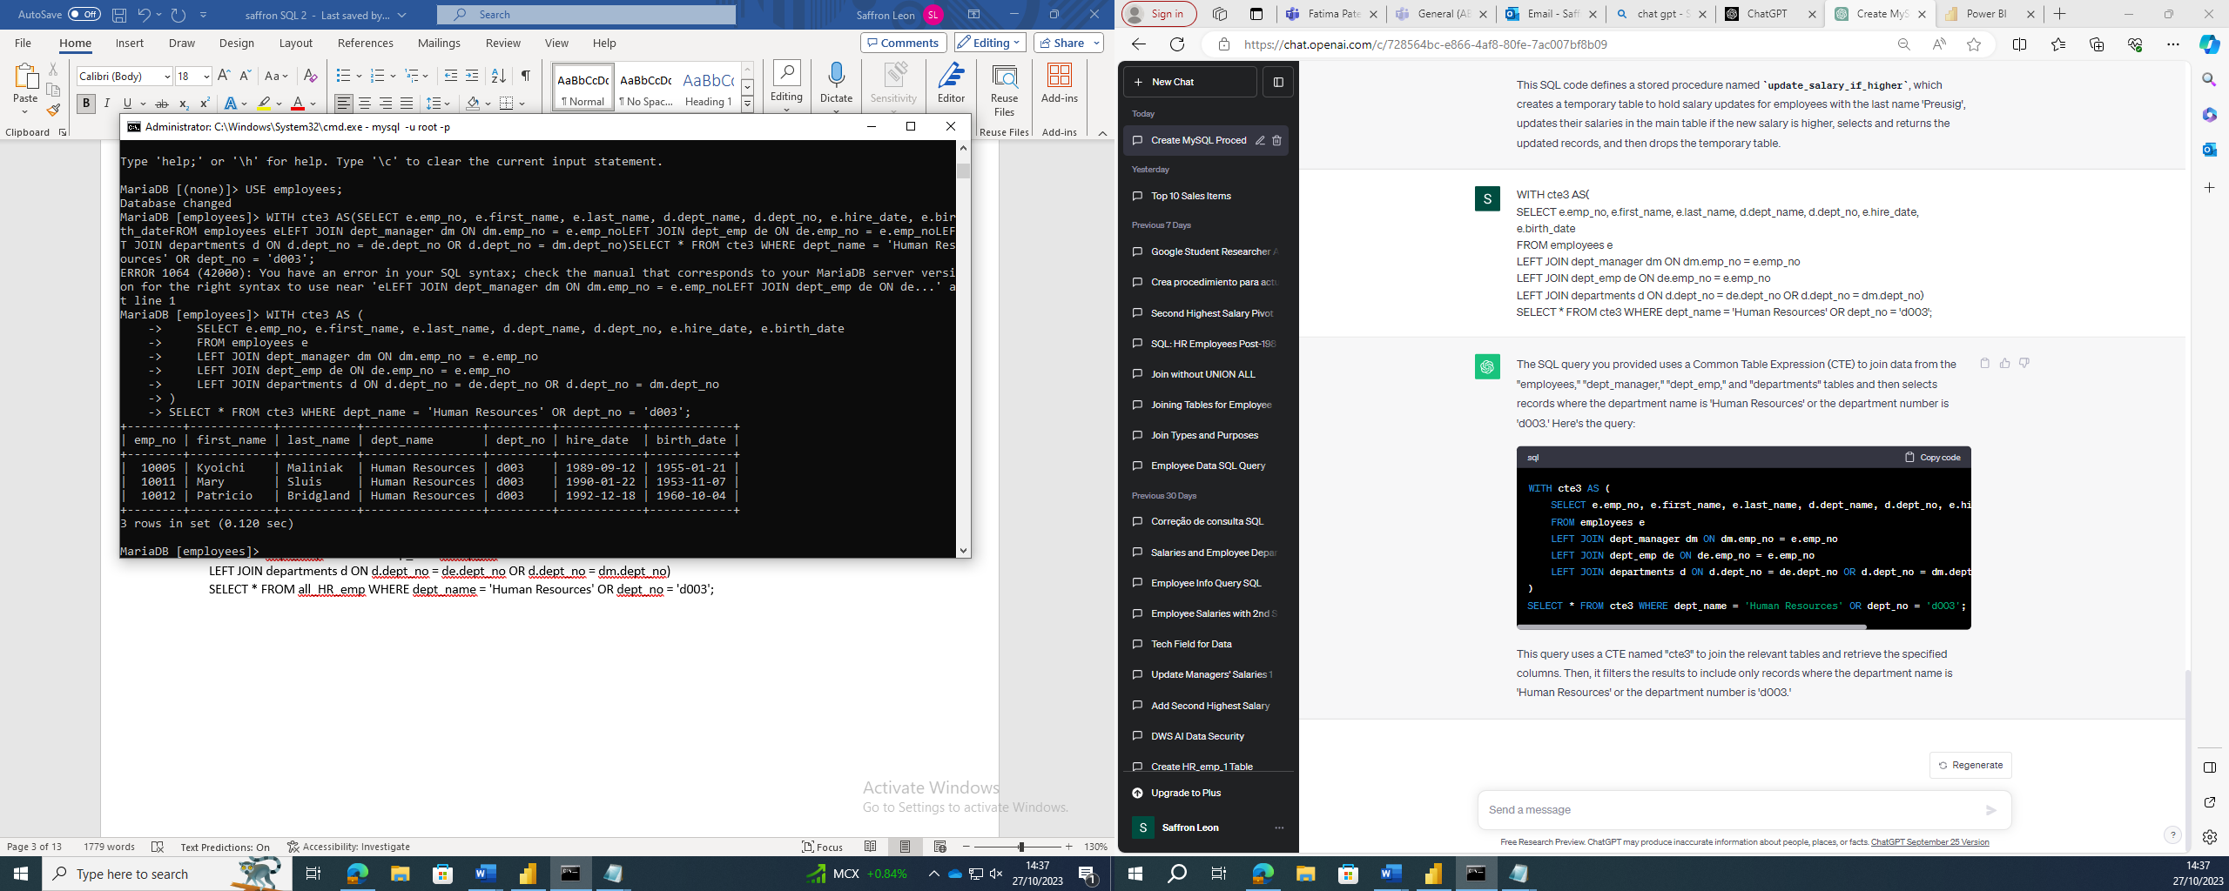

**4.** Create a SQL statement to show all departments and their department’s managers.

SELECT d.dept_name, CONCAT(e.first_name, ' ', e.last_name) AS manager_name

FROM

departments d

INNER JOIN dept_manager dm ON d.dept_no = dm.dept_no

INNER JOIN employees e ON dm.emp_no = e.emp_no

ORDER BY d.dept_name;

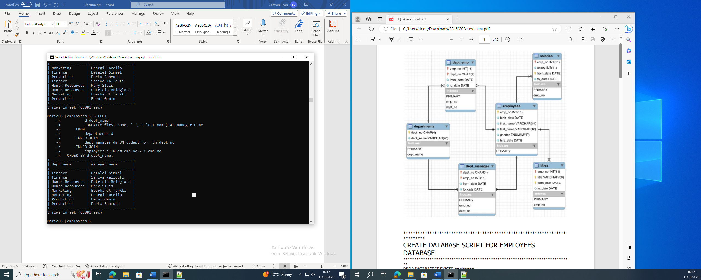

**5.** Create a SQL statement to show a list of HR’s employees who were hired after 1986.

WITH emp_mgr_HR AS

(SELECT e.emp_no, e.first_name, e.last_name, d.dept_name, d.dept_no, e.hire_date, e.birth_date

FROM employees e

LEFT JOIN dept_manager dm ON dm.emp_no = e.emp_no

LEFT JOIN dept_emp de ON de.emp_no = e.emp_no

LEFT JOIN departments d ON d.dept_no = de.dept_no OR d.dept_no = dm.dept_no)

SELECT *

FROM emp_mgr_HR

WHERE (dept_name = 'Human Resources' OR dept_no = 'd003') AND hire_date > '1986-01-01';

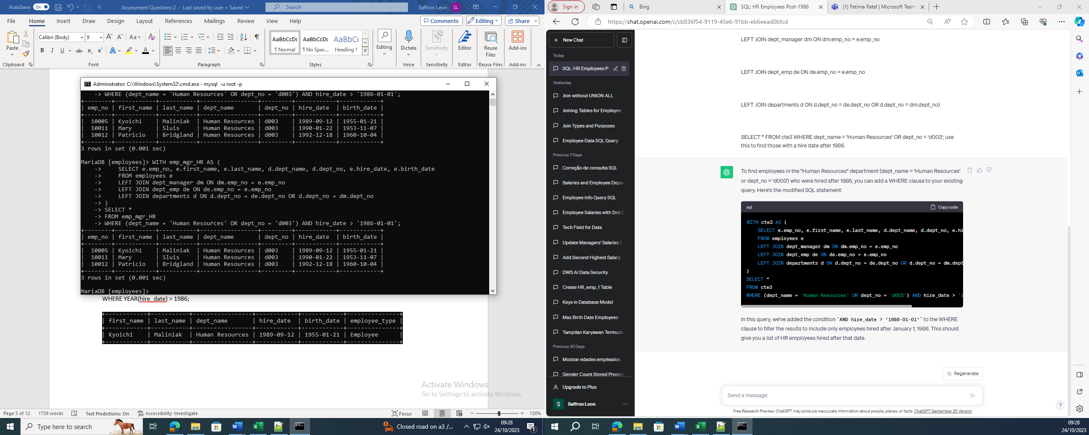

6. Create a SQL statement to increase any employee’s salary up to 2%. Assume the employee has just phoned in with his/her last name.

*Correction

As I cannot change/ alter the original data I will use a temporary table.

In this example Anneke Preusig is the employee:

DELIMITER $$

CREATE PROCEDURE update_salary_if_higher()

BEGIN

-- Create a regular table to hold updated salaries

CREATE TABLE temp_salary_update AS

SELECT e.emp_no, e.first_name, e.last_name,

s.salary * 1.02 AS salary

FROM salaries s

JOIN employees e ON s.emp_no = e.emp_no

WHERE s.emp_no IN (

SELECT emp_no

FROM employees

WHERE last_name = 'Preusig')

AND s.salary * 1.02 > s.salary;

-- Update the salaries in the main table

UPDATE salaries s

JOIN employees e ON s.emp_no = e.emp_no

SET s.salary = s.salary * 1.02

WHERE s.emp_no IN (

SELECT emp_no

FROM employees

WHERE last_name = 'Preusig')

AND s.salary * 1.02 > s.salary;

-- Select and return the updated records

SELECT * FROM temp_salary_update;

END $$

DELIMITER ;

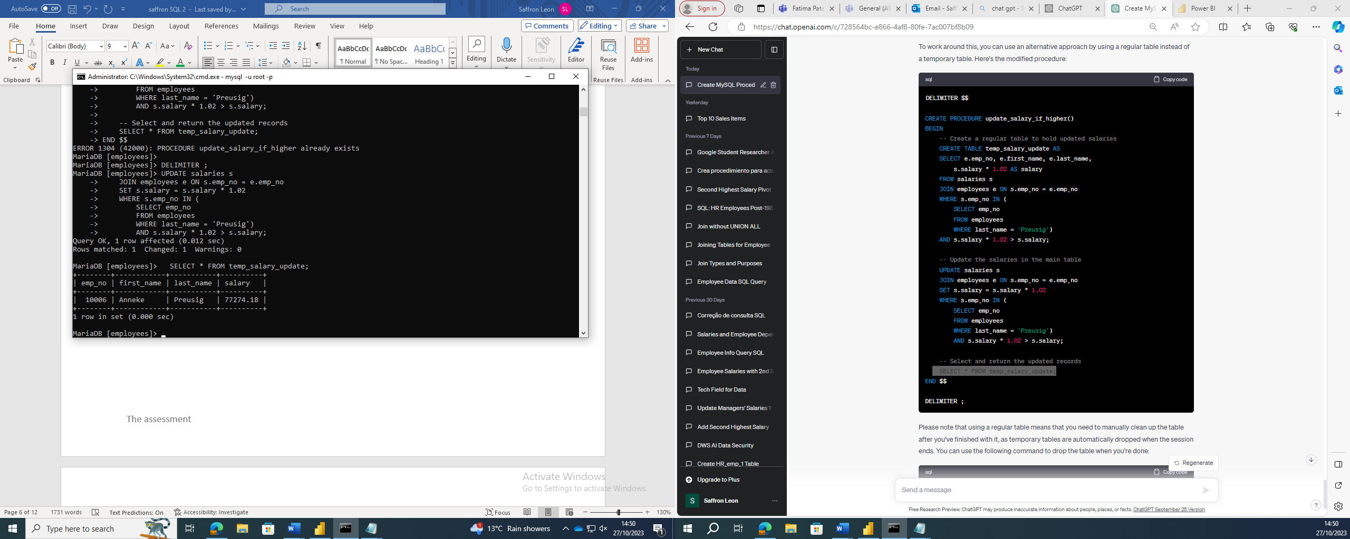

1. Create a SQL statement to delete employee’s record who belongs to marketing department and name start with A.

**There was no employee who worked in marketing department and whose first name begins with A.**

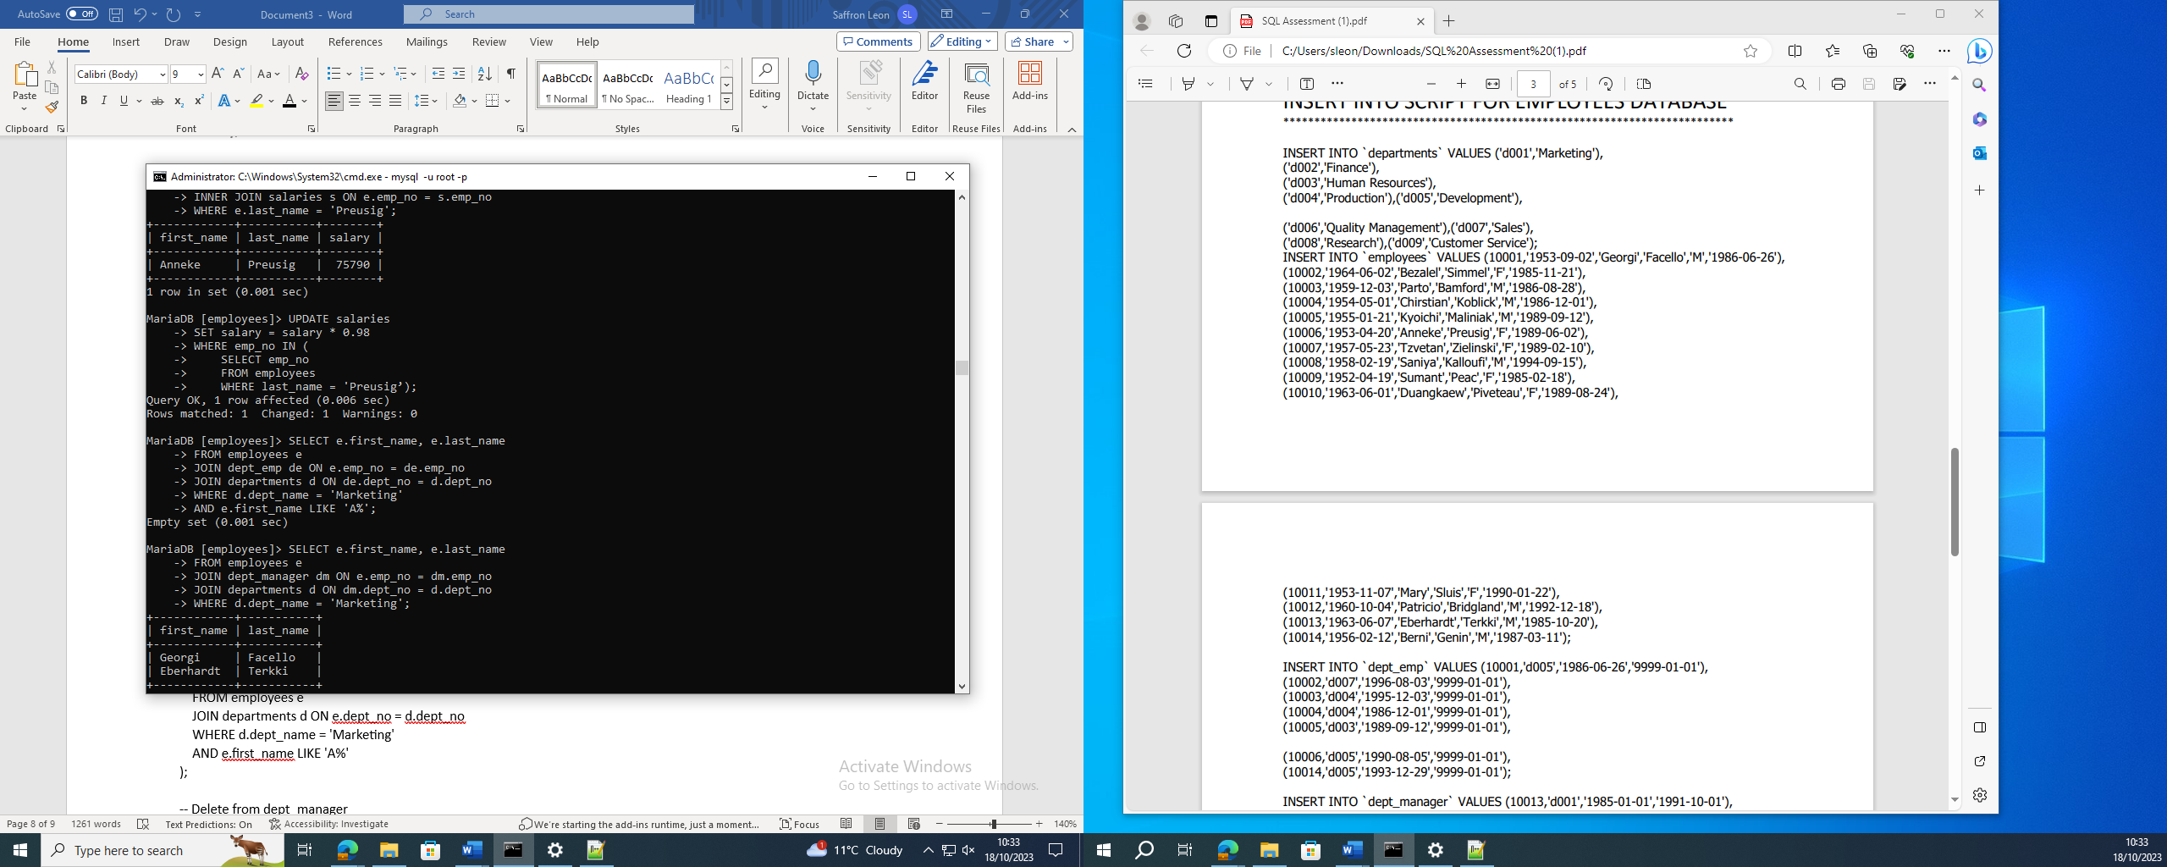SELECT e.first_name, e.last_name

FROM employees e

JOIN dept_emp de ON e.emp_no = de.emp_no

JOIN departments d ON de.dept_no = d.dept_no

WHERE d.dept_name = 'Marketing'

AND e.first_name LIKE 'A%';

**If there was:**

-- Delete from titles

DELETE FROM titles

WHERE emp_no IN ( SELECT e.emp_no

FROM employees e

JOIN departments d ON e.dept_no = d.dept_no

WHERE d.dept_name = 'Marketing'

AND e.first_name LIKE 'A%');

-- Delete from salaries

DELETE FROM salaries

WHERE emp_no IN (

SELECT e.emp_no

FROM employees e

JOIN departments d ON e.dept_no = d.dept_no

WHERE d.dept_name = 'Marketing'

AND e.first_name LIKE 'A%');

-- Delete from dept_manager

DELETE FROM dept_manager

WHERE emp_no IN (

SELECT e.emp_no

FROM employees e

JOIN departments d ON e.dept_no = d.dept_no

WHERE d.dept_name = 'Marketing'

AND e.first_name LIKE 'A%');

-- Delete from dept_emp

DELETE FROM dept_emp

WHERE emp_no IN (

SELECT e.emp_no

FROM employees e

JOIN departments d ON e.dept_no = d.dept_no

WHERE d.dept_name = 'Marketing'

AND e.first_name LIKE 'A%');

-- Finally, delete from employees

DELETE FROM employees

WHERE emp_no IN (

SELECT e.emp_no

FROM employees e

JOIN departments d ON e.dept_no = d.dept_no

WHERE d.dept_name = 'Marketing'

AND e.first_name LIKE 'A%');

1. Create a database view to list the full names of all departments’ managers, and their salaries.

**\*Assuming you do not know how many salaries one employee has.**

CREATE VIEW department_manager AS

SELECT CONCAT(e.first_name, ' ', e.last_name) AS manager_full_name,

IFNULL(d.dept_name, 'No Department') AS department_name,

MAX(CASE WHEN ranks.rnk = 1 THEN s.salary END) AS salary_1,

MAX(CASE WHEN ranks.rnk = 2 THEN s.salary END) AS salary_2

FROM

employees e

LEFT JOIN

dept_manager dm ON e.emp_no = dm.emp_no

LEFT JOIN

departments d ON dm.dept_no = d.dept_no

INNER JOIN

salaries s ON s.emp_no = e.emp_no

INNER JOIN (SELECT emp_no, salary, DENSE_RANK() OVER (PARTITION BY emp_no ORDER BY salary DESC) AS rnk

FROM

salaries) ranks ON s.emp_no = ranks.emp_no AND s.salary = ranks.salary

WHERE

ranks.rnk <= 2

GROUP BY

e.emp_no, manager_full_name, department_name

ORDER BY

e.emp_no;

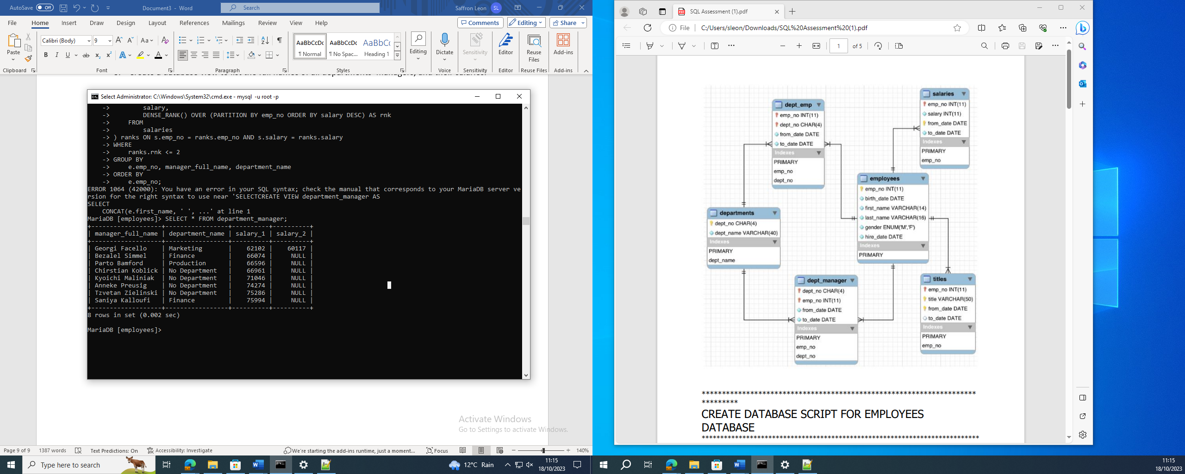

1. Create a database view to list all departments and their department’s managers, who were hired between 1980 and 1990.

I completed this question in two ways as I am not allowed to alter the data, but I thought I would give my reasoning.

**WAY 1:**

*After discovering that for some employees the hire_date was after the from_date I had to create a new Common Table Expression that replaced the hire_date with the from_date as it would be impossible for somebody to be working without being hired.

WITH EmployeeDates AS (SELECT e.emp_no, e.first_name, e.last_name, e.hire_date,

de.from_date AS dept_emp_from_date,

dm.from_date AS dept_manager_from_date,

s.from_date AS salaries_from_date,

t.from_date AS titles_from_date,

CASE

WHEN dm.from_date < e.hire_date THEN dm.from_date

ELSE e.hire_date

END AS updated_hire_date

FROM

employees e

LEFT JOIN

(SELECT emp_no, from_date FROM dept_manager) AS dm ON e.emp_no = dm.emp_no

LEFT JOIN

(SELECT emp_no, from_date FROM salaries) AS s ON e.emp_no = s.emp_no

LEFT JOIN

(SELECT emp_no, from_date FROM titles) AS t ON e.emp_no = t.emp_no

LEFT JOIN

(SELECT emp_no, from_date FROM dept_emp) AS de ON e.emp_no = de.emp_no)

SELECT

emp_no,

first_name,

last_name,

hire_date,

dept_manager_from_date,

salaries_from_date,

titles_from_date,

dept_emp_from_date,

updated_hire_date

FROM

EmployeeDates;

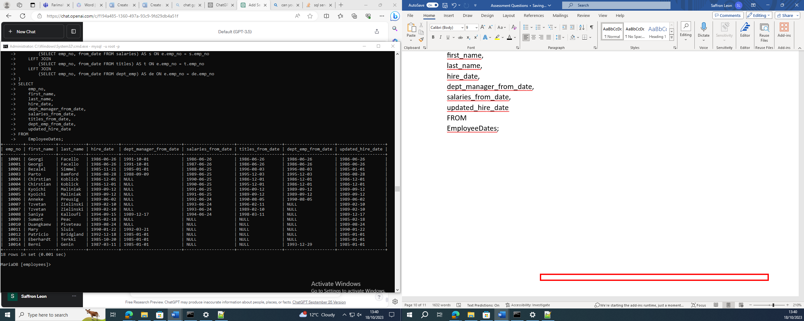

The CTE :

CREATE VIEW ManagerHireDatesView AS

Replace the hire date with the proper hire date.

WITH ManagerDates AS (SELECT e.emp_no, e.first_name, e.last_name, e.hire_date,

dm.from_date AS dept_manager_from_date,

CASE

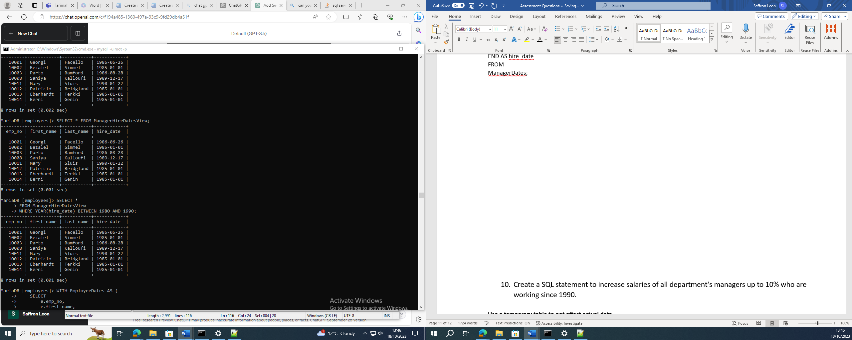WHEN dm.from_date < e.hire_date THEN dm.from_date

ELSE e.hire_date

END AS updated_hire_date

FROM

employees e

INNER JOIN

dept_manager dm ON e.emp_no = dm.emp_no)

SELECT emp_no, first_name, last_name,

CASE

WHEN updated_hire_date < hire_date THEN updated_hire_date

ELSE hire_date

END AS hire_date

FROM

ManagerDates;

And then: SELECT *

FROM ManagerHireDatesView

WHERE YEAR(hire_date) BETWEEN 1980 AND 1990;

Way 1:

LEFT JOIN with dept_manager: allows you to include the "department manager from date" in your result set. In case an employee is not a department manager, a LEFT JOIN ensures that the employee's record will still be included in the result with a NULL value for the "department manager from date."

LEFT JOIN with salaries: gives you the "salaries from date" for each employee. Again, if an employee does not have a salary record, a LEFT JOIN ensures their record is included with a NULL value for the "salaries from date."

LEFT JOIN with titles: allows you to retrieve information about job titles held by employees, specifically the "titles from date." As with the other joins, a LEFT JOIN ensures that employees without title records are still included in the result with a NULL value for the "titles from date."

LEFT JOIN with dept_emp: associates employees with their department information, providing the "department employee from date." Like the other joins, a LEFT JOIN ensures that all employees, whether or not they are currently in a department, are included in the result set.

WAY 2:

*Assuming that the data was correct, and I do not need to alter It.

CREATE VIEW department_managers_between_1980_and_1990 AS

SELECT d.dept_name AS department_name,

CONCAT(e.first_name, ' ', e.last_name) AS manager_name,

e.hire_date AS manager_hire_date

FROM employees e

INNER JOIN dept_manager dm ON e.emp_no = dm.emp_no

INNER JOIN departments d ON dm.dept_no = d.dept_no

WHERE YEAR(e.hire_date) BETWEEN 1980 AND 1990;

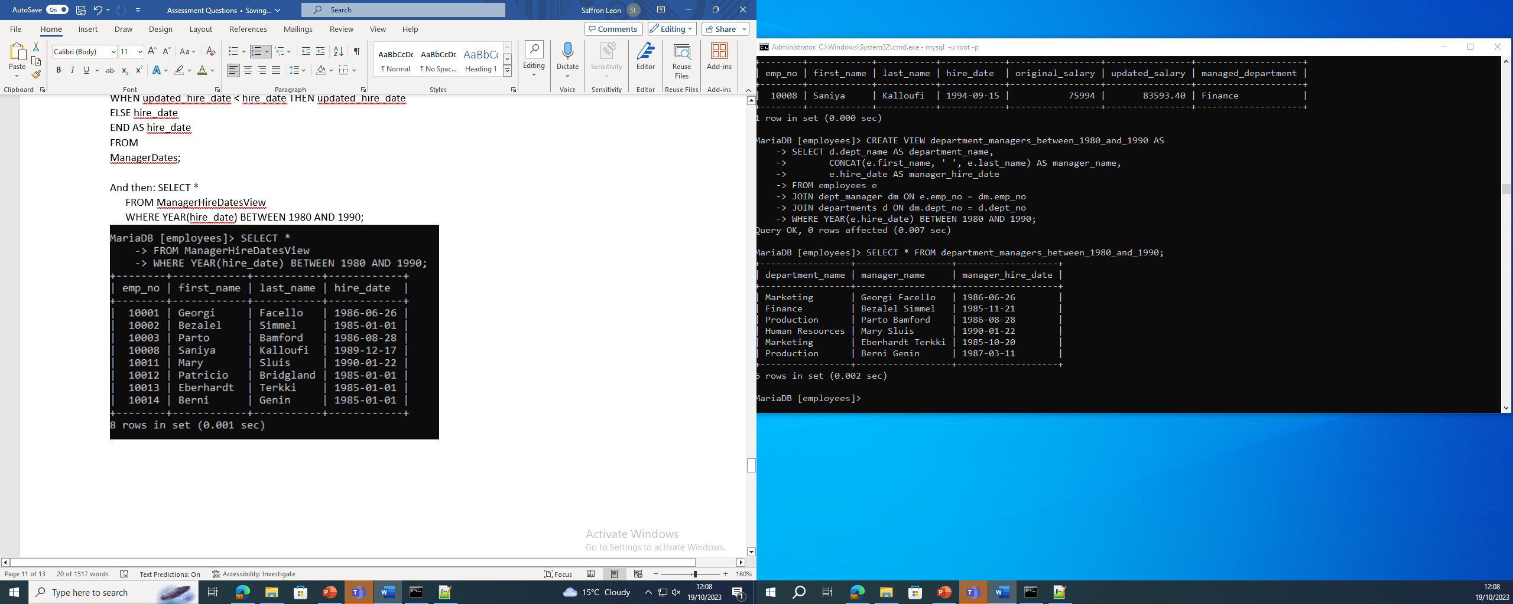

1. Create a SQL statement to increase salaries of all department’s managers up to 10% who are working since 1990.

*Correction

SELECT e.emp_no, e.first_name, e.last_name, s.salary AS current_salary, s.salary * 1.10 AS updated_salary

FROM dept_manager dm

LEFT JOIN employees e ON dm.emp_no = e.emp_no

LEFT JOIN salaries s ON e.emp_no = s.emp_no

WHERE YEAR(e.hire_date) >= 1990;

